Contact Page

Definition
# Source: AI Source: Provided by: [Data Path: Persons Table -> ID Column: 1, Name_En Column: Motasem Essam] -> From: [Chatgpt (GPT‑5 Mini)] on [2/12/2026]
A Contact Page is a web page that provides ways for visitors to get in touch with a person, company, or organization.

Simple Definition
# Source: AI Source: Provided by: [Data Path: Persons Table -> ID Column: 1, Name_En Column: Motasem Essam] -> From: [Chatgpt (GPT‑5 Mini)] on [2/12/2026]
Contact Page = a page that shows how people can contact you.

What a Contact Page Usually Includes
# Source: AI Source: Provided by: [Data Path: Persons Table -> ID Column: 1, Name_En Column: Motasem Essam] -> From: [Chatgpt (GPT‑5 Mini)] on [2/12/2026]
- Contact form – visitors can send a message directly from the website
- Email address – for communication
- Phone number – for calls or WhatsApp
- Physical address (optional) – office or business location
- Map (optional) – shows your location (Google Maps embed)
- Social media links (optional) – Facebook, Instagram, LinkedIn, etc.

Purpose of a Contact Page
# Source: AI Source: Provided by: [Data Path: Persons Table -> ID Column: 1, Name_En Column: Motasem Essam] -> From: [Chatgpt (GPT‑5 Mini)] on [2/12/2026]
- Let visitors ask questions or get support
- Help customers reach the business easily
- Allow potential clients to request services or information
- Build trust and communication

Example
# Source: AI Source: Provided by: [Data Path: Persons Table -> ID Column: 1, Name_En Column: Motasem Essam] -> From: [Chatgpt (GPT‑5 Mini)] on [2/12/2026]
- A business website → customers send inquiries
- A freelancer portfolio → clients request projects
- An organization → people ask for information or help

Difference Between Contact Page and About Page
# Source: AI Source: Provided by: [Data Path: Persons Table -> ID Column: 1, Name_En Column: Motasem Essam] -> From: [Chatgpt (GPT‑5 Mini)] on [2/12/2026]
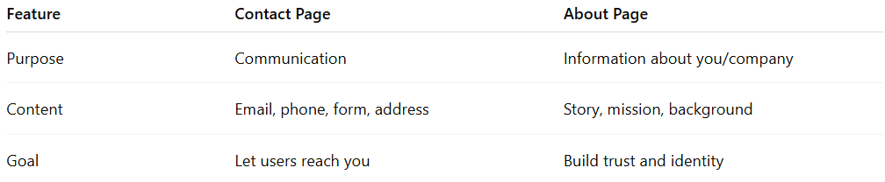
Feature | Contact Page | About Page
Purpose | Communication | Information about you/company
Content | Email, phone, form, address | Story, mission, background
Goal | Let users reach you | Build trust and identity

